Quick View

Once you open the Expense Tracker Workbook in Excel, you will find 2 sheets in there. If you see below, you can Expense Entry Sheet and Quick Expense Calculator.
Expense Entry is where you will enter data
Below is how it looks:
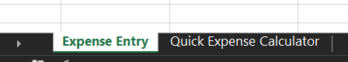

I put some dummy data into the table to clearly show how it looks if the table has data.
Some dummy data below:
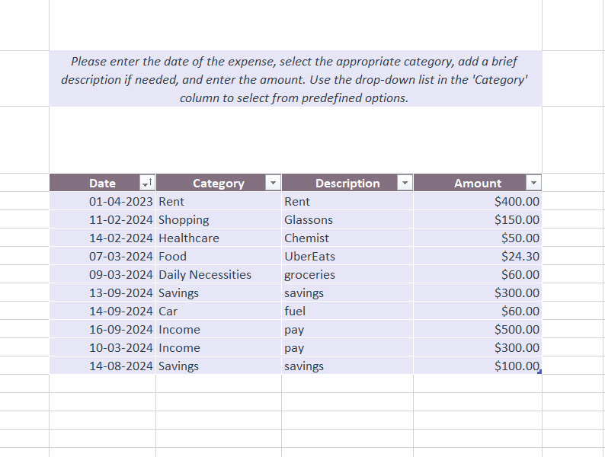
Description is Optional. You can enter to be more specific. Only useful to check and it doesn’t affect the tables in the Quick Expense Calculator

This is how it looks if the year and month selected has data. Only year and month are editable. Further Instructions about each cell and/or table are in the sheet on the right for clear understanding.
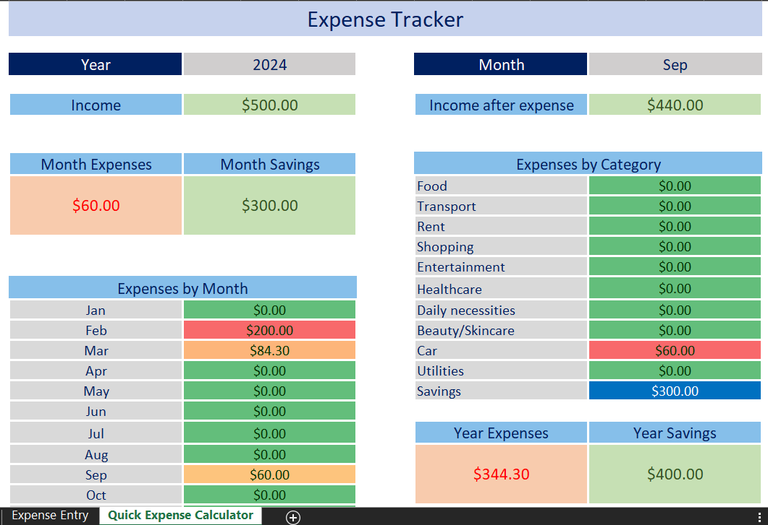

Only these are editable.

This is how your Expense Entry Sheet looks. Enter data
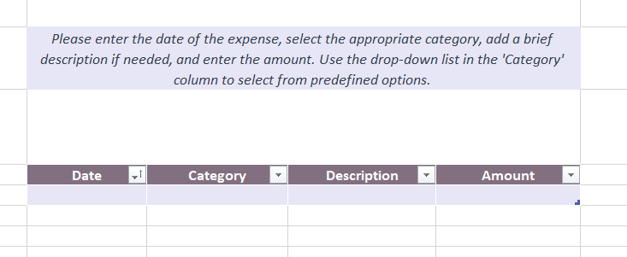

This is how your Quick Expense Calculator looks since the table has no data
